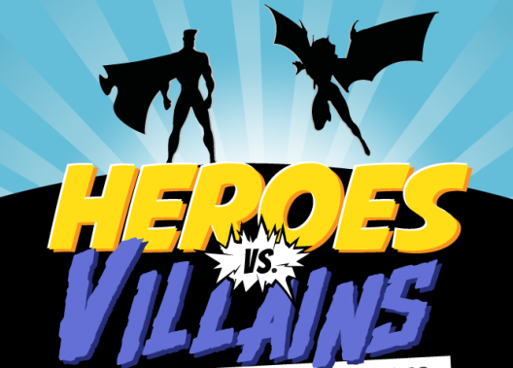
Heroes & Villians!
TOLO 2018
When: Thursday, October 25, 2017 (6:45-9 pm)
Who is invited? All High School Students! (Dates are not required)
Location: Flying Circus
455 Andover Park East, Tukwila, WA 98188
425-669-9707 / https://www.flyingcircus.us/
Theme: Heroes & Villains
Dress: Come as either a hero or a villain! Ideas: Mr. Incredible, Syndrome, Lava Girl, Captain America, Metro Man, Megamind, Thor, Loki, Black Widow, Harry Potter, Lord Voldemort
Please abide by the SCS dress code
Waiver Form: A Waiver Form is required to attend the event. YOU WILL NEED TO TURN IN YOUR WAIVER FORM WHEN YOU BUY YOUR TICKETS. No waiver, no ticket. Waivers will be available through ASB or the secondary office.
Tickets: $15 per person. Includes entrance fee, venue approved socks, unlimited fun, snacks, and drinks. It does not include professional pictures provided by Mike Fiechtner Photography.
Pictures: Pictures provided by Mike Fiechtner Photography. Packages range from $10-$60.
Transportation: SCS will not provide transportation. Please carpool with friends! Parking is free.
Guests: This is an SCS event. You MAY bring people from outside of school, but please remember that they, as well as you, are representing SCS. You must fill out a Guest Participation Form and Waiver Form, and turn it in to the office by Monday, October 22.

